EXPERIMENT 3

1) Write a HTML code to generate following output:-Style the table with white borders and a background color of the cells to make the impression of invisible borders.
Course | Year Of Passing | Percentage
BCA | 2010 | 85
MCA | 2012 | 80
M.Tech | 2014 | 87

2) Create the following table using HTML.

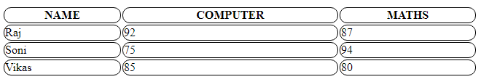

3. Write a HTML code with one header row, three data row (total 4 rows and three columns and set the width of the table as 100%. Now change the width of the 2nd column to 60. Again change the height of the 1st row to 150 pixels

4. Create the following table using HTML

TIME TABLE
 | 9-10 | 10-11 | 11-12 | 12-13 | 13-14
MON | Computer | Maths | English | History | Hindi
TUE | Maths | Hindi | History | Hindi | Computer
WED | Engish | History | Computer | Maths | English
THU | History | English | Hindi | Computer | Maths
FRI | Hindi | Computer | Maths | English | History

